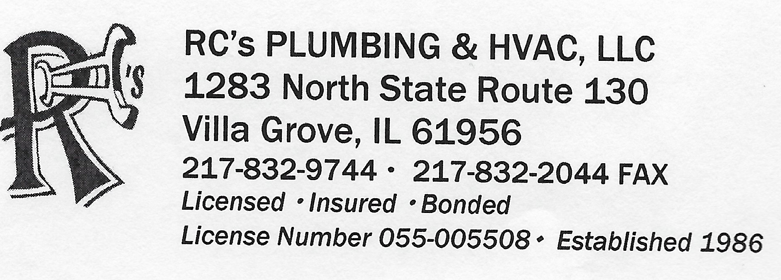

September 21, 2015
Inspection reports follows:
For freezing to occur in any H2O system in central Illinois.
Not only does the temperature need to be at or below freezing, but the introduction of cold air into the space exponentially speeds up the freezing even if the space heat is above 50 degrees. When the pipes are exposed to below freezing air, for even a short period of time, the pipe and fittings will freeze and burst.
Even with no heat in a basement most pipes wont freeze since they are in a constant 55 degree room. If there is enough infiltration of cold out side air being pushed by wind,the wind will cause the pipes to freeze solid and burst. Basements are subject to freezing pipes if the temperature dips low enough due to an air introduction of cold air.
I have seen in my 30 years of plumbing experience that even in heated basements, that the pipes will freeze if the is an influx of cold air driven by a strong wind and/or there are air leaks in the foundations or doors.
There were 3 large air infiltration areas at the time of my inspection , all three were directly located to the east tenants over head door. Approximately one half to three quarters of a gap on both side and approximately three eights of a gap under the door.
To keep the pipes in question, in a liquid state, those infiltration spots must be sealed and that tenant space heated to the normal 74 degrees.
The wet fire suppression malleable 2 inch elbow closest to the east end of the building ruptured and broke. It is located approximately 9 feet above the basement floor and 12 feet from the exterior wall, where the tenant turned off the heat and allowed the air infiltration areas not corrected. Observed directly above the elbow was a space below the overhead door on both sides through which light could be seen. There is a direct correlation between exterior light that can be seen from the inside and the temperature change and influx of wind and air.
In my opinion, with the presence of the 2 additional ruptured and burst fittings, this indicates a freeze burst situation. They are located 25 feet father west and 8 feet lower from the ruptured 2 inch cast iron elbow and are still present for inspection. Both are 1.5 inch galvanized tees.

Presure ratings of the following 2 inch fittings:
Malleable 90 degree elbow: 175 PSI
Black iron 90 degree elbow: 300 PSI
Galvanized iron pipe 90 degree elbow: 1000 PSI

